**FIRE FIGHTING ROBOT**

# Abstract

This fire-fighting robot is an innovative solution designed to detect and extinguish fires autonomously. At its core, an Arduino board orchestrates the operations, processing signals from an MQ2 smoke sensor and multiple flame sensors positioned strategically for 360-degree fire detection. The robot employs a servo motor to maneuver a water pump, which is activated via a relay module to douse flames effectively. Mobility is achieved through DC motors controlled by an LM293D motor driver, ensuring agile navigation. The entire system is powered by a series of 18650 batteries, providing a reliable power source for extended missions. This robot represents a significant advancement in automated safety technology, with potential applications in various high-risk environments.

# Key Features

**1.Arduino Control**: Utilizes an Arduino board as the central processing unit for managing operations.

**2.Smoke Detection**: Equipped with an MQ2 gas sensor to detect smoke.

**3.Flame Detection**: Includes four flame sensors for comprehensive fire detection in multiple directions.

**4.Fire Extinguishing Mechanism**: Features a servo motor to position the water pump, controlled by a relay module, for extinguishing fires.

**5.Mobility**: Employs DC motors driven by an LM293D motor driver for agile movement.

**6.Power Supply**: Powered by two 18650 batteries connected in series to ensure a reliable and long-lasting power source.

**DESIGN**

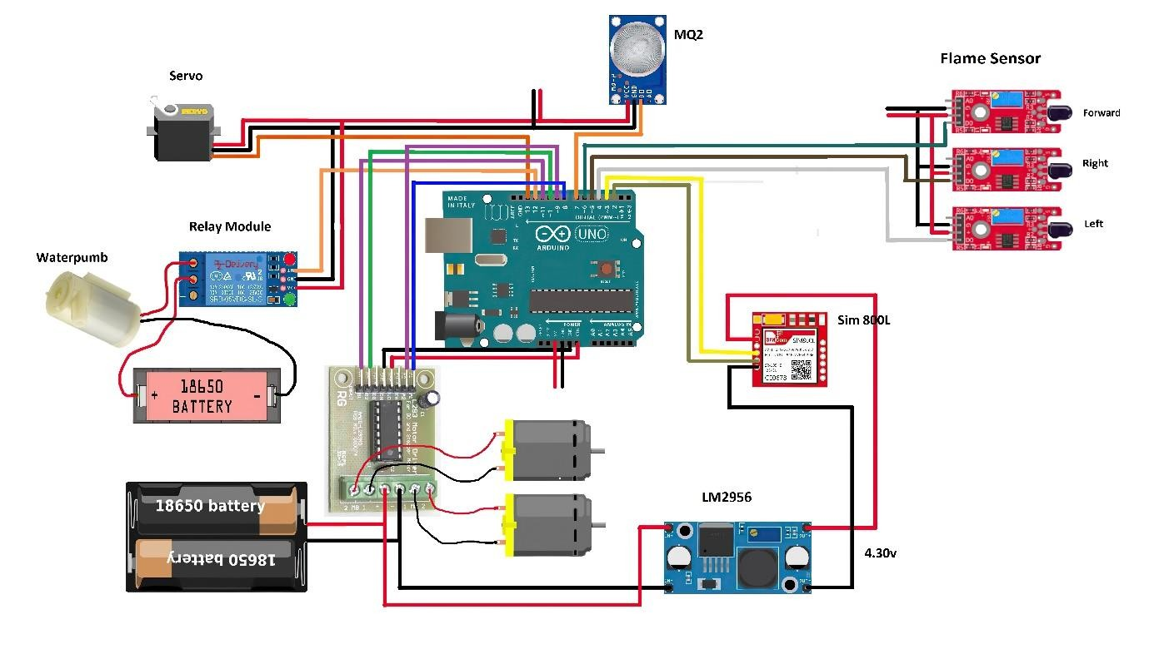

# COMPONENTS REQUIRED

1. Ardunio Uno
2. Relay Module
3. Water Pump
4. Flame Sensor
5. Two 18650 Battery
6. Servo
7. L293 Motor driver
8. 2 Motors
9. LM2956 Module

**OUTPUT**

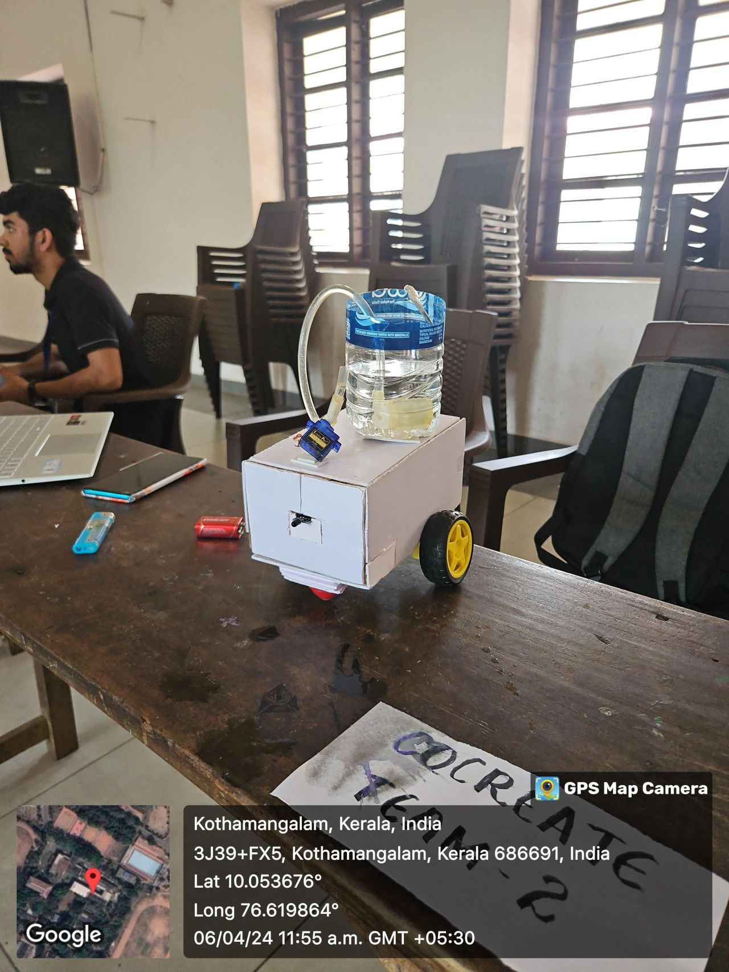

Successfully detected fire sources and automatically activated the water pump to extinguish flames, demonstrating effective real-world fire mitigation capabilities.